Computer Organization & Architecture Lab

PROJECT PROPOSAL



Submitted By:

Muhammad Umar Jan (21PWCSE2000)

Muhammad Saad (21PWCSE1997)

Abdul Moiz Malik (21PWCSE2006)

Section: “B”

Submitted to:

Dr. Bilal Habib

Department of Computer Systems Engineering

University of Engineering and Technology, Peshawar.

**SAP(Simple As possible Computer)-1**

**INTRODUCTION:**

Simple as Possible (SAP) computers in general were designed to introduce beginners to some of the crucial ideas behind computer operations. SAP computers are classified into stages, each stage more evolved and considering more advanced concepts in computer architecture than the previous. The SAP-1 computer is the first stage in this evolution and contains the basic necessities for a functional computer. Its primary purpose is to develop a basic understanding of how a computer works, interacts with memory and other parts of the system like input and output. The instruction set is very limited and is simple.

**SAP-1 COMPONENTS:**

* Program Counter
* Input and Memory Address Register (MAR)
* Random-Access Memory (RAM
* Instruction Register ✓ Controller-Sequencer ✓ Accumulator:
* Adder-Subtractor
* B-Register
* Output Register
* Binary Display

**SAP-1 INSTRUCTION SET:**

The instruction set of a computer are the basic

operations it can perform. The instruction set of the SAP-1 is described in table below.

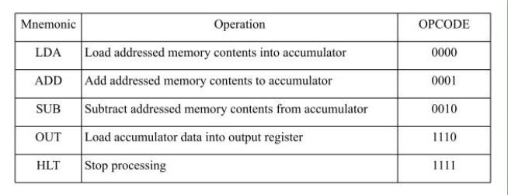

**SAP**

**-**

**1**

**ARCHITECTURE**

**:**

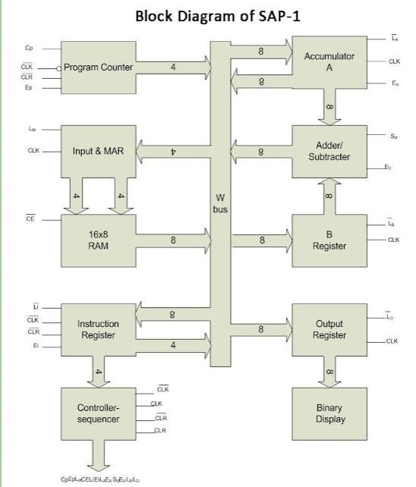

**WORKING:**

The SAP-1 computer, designed as a teaching model, features essential components like registers (IR, MAR, MBR, AC), an ALU for arithmetic and logic operations, and a control unit. Its instruction cycle involves fetching, decoding, and executing instructions from memory. With a limited instruction set, it performs operations like addition, subtraction, storing, and loading data. The data path facilitates movement between registers, ALU, and memory, while the control unit manages timing and control signals for proper sequencing of operations. SAP-1 serves as an educational tool to illustrate core computer architecture concepts, making it a foundational model for understanding basic computing principles.

**CONCLUSION:**

The SAP-1 (Simple As Possible) computer, while a fundamental and educational model, has limitations due to its simplicity. It provides a clear demonstration of basic computer architecture principles, such as registers, ALU, memory interaction, and control flow. However, its minimal instruction set and basic design make it inadequate for real-world applications or modern computing needs. The conclusion drawn from SAP-1's design lies in its effectiveness as a learning tool for comprehending core computer concepts but acknowledges its impracticality for contemporary computing tasks due to its rudimentary nature and limited capabilities.

**REFRENCE:**

* [https://eightify.app/summary/programming-and-artificial-intelligence/designand-functioning-of-sap-1-architecture-based-8-bit-computer](https://eightify.app/summary/programming-and-artificial-intelligence/design-and-functioning-of-sap-1-architecture-based-8-bit-computer)
* https://deeprajbhujel.blogspot.com/2015/12/sap-1-architecture.html